**Holmesdale Infant School**

**Mixing Classes Policy**

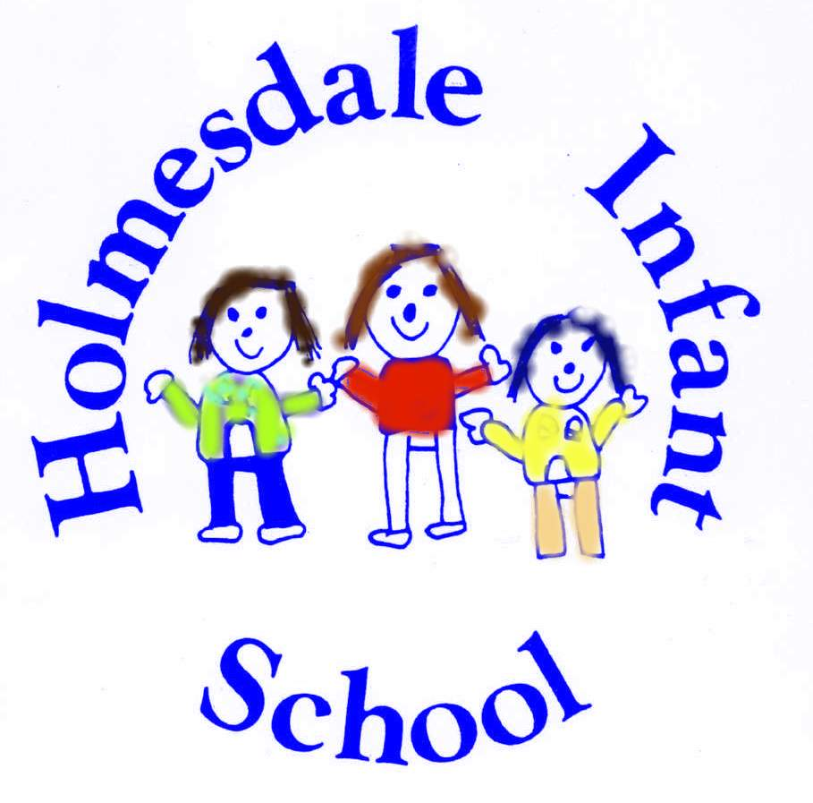

**Holmesdale Infant School**

**Class Mixing Policy**

At Holmesdale Infant School we will review classes each year and mix classes dependent on needs of the school and children and to ensure that:

• There are opportunities for children to learn and play with a wider variety of peers

• To enable greater social interaction between children as they move through the school

• To ensure that the classes remain balanced in response to pupil transfer and transition during phases

• To promote a greater sense of community

**Principles**

• The arrangements for class mixing are based on the professional judgements of Class Teachers, the Senior Leadership Team (SLT) and the Headteacher

• We will always consider what is in the best interests of individual children and classes as a whole when making decisions.

• We will always consider the happiness and welfare of the children and will take into consideration existing friendship groups when we create new classes. The children will be asked to name three children they may like to be in a class with. When teachers organise classes they will ensure that the child is in a class with at least one of the named friends.

**THE PROCESS**

• Class Teachers and Teaching Assistants observe the children’s friendships at work and play

• Class teachers and SENDCo advise the Headteacher on workable groupings for children in their classes

• SLT ensure a good balance of friendships, range of educational, social and personal needs, gender and maturity are represented in each class

• SLT meets with Class Teachers to discuss and finalise groupings

• Headteacher and Senior Leadership Team and SENDCo meet and approve classes

• This decision is final. Children will not be moved as this inevitably involves the movement of other children

• New Classes are shared with parents and children in the second half of the Summer term.

**CRITERIA FOR CLASS MIXING**

Classes will be mixed to achieve a good balance according to the following criteria:

• Date of birth

• Gender

• Ability levels

• Range of special educational, social and personal needs

• Friendships*

*Friendships: Over the course of their Primary years, children will have a range of friendship experiences. We find that with children some friendships can be very fluid, whilst others can stand the test of time. With that in mind and to inform our decision making as we prepare to draw up the class lists, we will use: observations of the children in the classroom and at play and the children’s list of three they may want to be in a class with. They will be with at least one of the three.

**MAKING PARENTS AWARE OFSCHOOL POLICY**

• Parents are informed of the mixed class policy when they visit the school

• Policy is on the website

•The policy is in the school prospectus and welcome pack

Any concerns should be shared with the Headteacher who will reassure the parents about their child’s class allocation. The organization of classes is carefully considered to enhance the learning opportunities of **all** the children at Holmesdale Infant school. The Headteacher’s motivation when organising classes is to protect the teaching and learning interests of the whole school, making the best decisions in the interests of all the pupils, not one pupil or one class.

If a parent feels that the Mixing Classes Policy has not be adhered to they can in the first instance raise their concerns with the Headteacher, if still not satisfied they should follow the complaints procedure which is available on the school website.

Policy reviewed and agreed Spring Term 2023 Policy

(Review is subject to amendment via addendum in extreme circumstances)

**TIMESCALES IF CHANGES ARE TO BE MADE:**

• Class Teachers and Teaching Assistants discuss their observations of friendships in the Summer Term

• Observations are considered along with the criteria listed above after May half-term

• Class lists are drawn up by teachers and shared with SLT (June)

• Class lists approved by Headteacher (July)

• Class lists communicated to parents and children in July as part of the end of year arrangements.

**REVIEW**

The Policy will be reviewed annually and agreed by the Governing Body.

The Headteacher and Senior Leadership Team will review the process and criteria for each year’s class mixing arrangements.

Policy Reviewed and agreed by HGB Summer Term 2020 Policy Reviewed: Annually 2